Practice 12

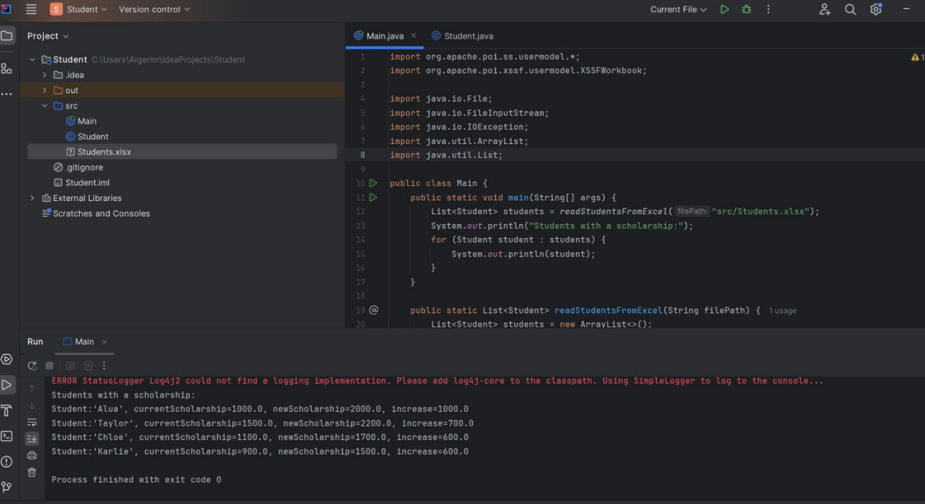

List<Student> students = readStudentsFromExcel("src/Students.xlsx");

It helps to read info about students ,from an Excel file and stores the results in a list.

public static List<Student> readStudentsFromExcel(String filePath)

It reads data from the Excel file and returns a list of students.

List<Student> students = new ArrayList<>();

Creates our Student list

try (FileInputStream fis = new FileInputStream(new File(filePath)); Workbook workbook = new XSSFWorkbook(fiss)

It will open our file and read it like a workbook.

Sheet sheet = workbook.getSheetAt(0);

Gets the first sheet in the Excel file

for (Row row : sheet) -Loops through all the rows in the sheet.

String name = row.getCell(0).getStringCellValue();

Gets student’s name from 1st column

double currentScholarship = row.getCell(1).getNumericCellValue();

gets current scholarship from 2nd column.

double newScholarship = row.getCell(2).getNumericCellValue();

gets the updated version from 3rd column.

students.add(new Student(name, currentScholarship, newScholarship));

Creates a new Student object with this data and adds it to the list.